ESE 448, HW 1

1. Lorenz equations with parameters $ρ=10; σ=1.1; β=2/3$

1.1 **Phase Portrait Plot**

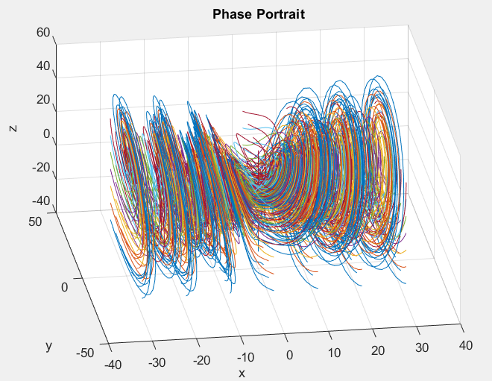

1.2 **Vector Field Plot**

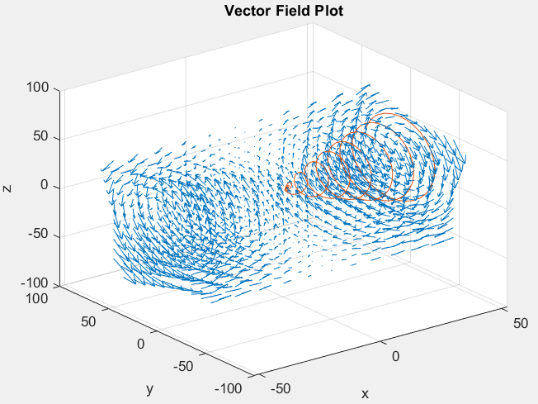

1.3 **Time Series Plot**

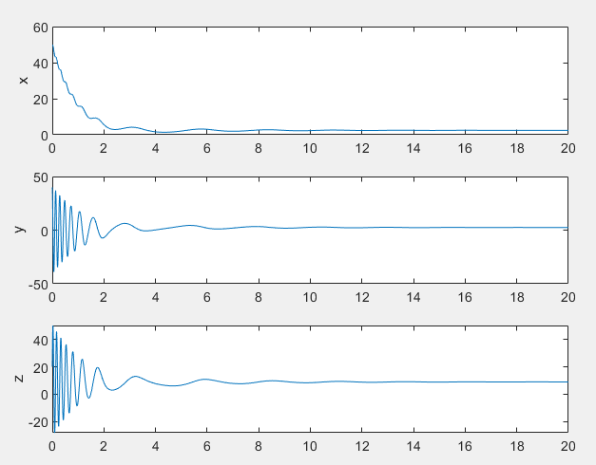

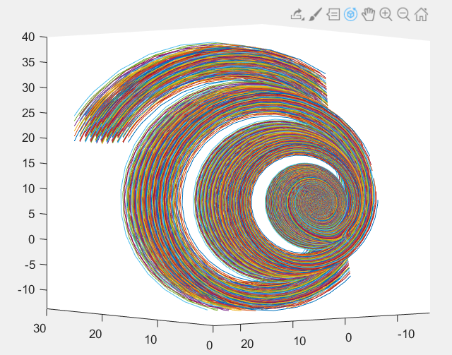*Does the system exhibit chaos?*

No. The figure to the right shows a plot of a grouping with slightly varied initial conditions, which follow similar behavior.

*Does the system oscillate?*

Yes. As shown in the time series plot in part 1.3, the $y$ and $z$ components have damped oscillations as they approach the stable critical point.

*Are there multiple modes of behavior?*

Yes. There is different behavior in the different directions, (Damped oscillations in $y,z$, simple damping in $x$ as the dominant modes).

*Do trajectories approach a critical point?*

Yes. As shown in the time series in 1.3, the critical point is $≈$ (2.44, 2.45, 8.97)

%parameters of Lorenz Eq'ns

rho = 10;

sigma = 1.1;

beta = 2/3;

%define system of ODEs

f = @(t,x) [sigma*(x(2)-x(1));x(1)*(rho-x(3))-x(2);x(1)*x(2)-beta*x(3)];

%Create grid for phase portrait (x,y,z have same values)

x = -30:10:30;

%size of gride

len = length(x)^3;

%create empty array to hold ode45 sol'ns for all points in grid

t_phase = zeros(len,4000,1);

X_phase = zeros(len,4000,3);

%nth data point (n=1:len)

n=1;

for i=1:length(x)

for j=1:length(x)

for k=1:length(x)

%solve for each point on grid

[t,X]= ode45(f, [0 20], [x(i) x(j) x(k)]);

soln_len = length(t);

%append 0s to sol'n to make it same dims as t_phase, X_phase

t(numel(t_phase(n,:))) = 0;

X(numel(t_phase(n,:)),:) = 0;

%store the values of the sol'n

t_phase(n,:) = t;

t_phase(n,1) = soln_len; %stores the num steps of the sol'n

X_phase(n,:,:) = X;

n=n+1;

end

end

end

% PHASE PORTRAIT

figure;

%plots all sol'ns

for n=1:len

%plots only the number of steps in the sol'n for each initial condition

plot3(X_phase(n,1:t_phase(n,1),1), X_phase(n,1:t_phase(n,1),2), X_phase(n,1:t_phase(n,1),3));

hold on;

end

grid on;

title('Phase Portrait');

xlabel('x');

ylabel('y');

zlabel('z');

%VECTOR FIELD

%create grid

[x,y,z] = meshgrid(-50:10:50);

%calculate force vector at each point

u = sigma.*(y-x); %x_dot

v = x.*(rho-z); %y_dot

w = x.*y-beta.*z; %z_dot

%calculate one random sol'n to plot for reference in field graph

[t,X] = ode45(f, [0,20], [50,40,20]);

figure;

%quiver plots vector field for each point in the mesh

quiver3(x,y,z,u,v,w,3);

hold on;

plot3(X(:,1), X(:,2), X(:,3));

grid on;

title('Vector Field Plot');

xlabel('x');

ylabel('y');

zlabel('z');

%TIME SERIES

%uses sol'n from ode45 in vector field

figure;

%subplots x,y,z over time for sol'n

subplot(3,1,1);

plot(t,X(:,1));

ylabel('x');

subplot(3,1,2);

plot(t,X(:,2));

ylabel('y');

subplot(3,1,3);

plot(t,X(:,3));

ylabel('z');

2.1

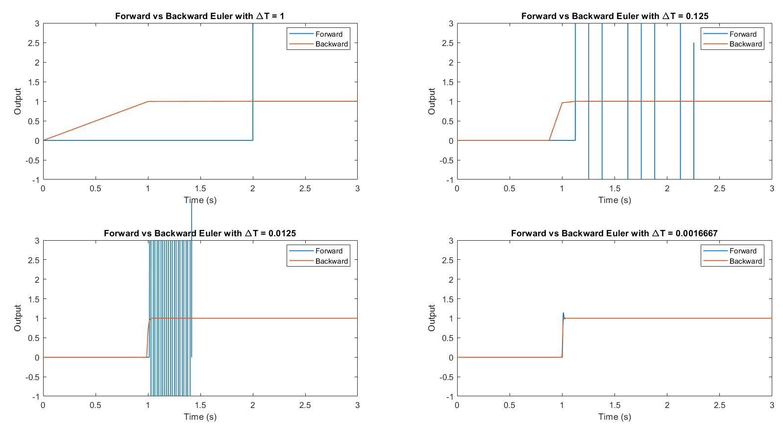For this problem, I wrote a script that ran the forward and backward euler transforms for each time step in $ΔT=[1, 1/8, 1/80, 1/600]$ and plotted them next to eachother. The backward difference was stable for all timesteps, but the forwards one was stable only for the smallest.

Simulink Model:

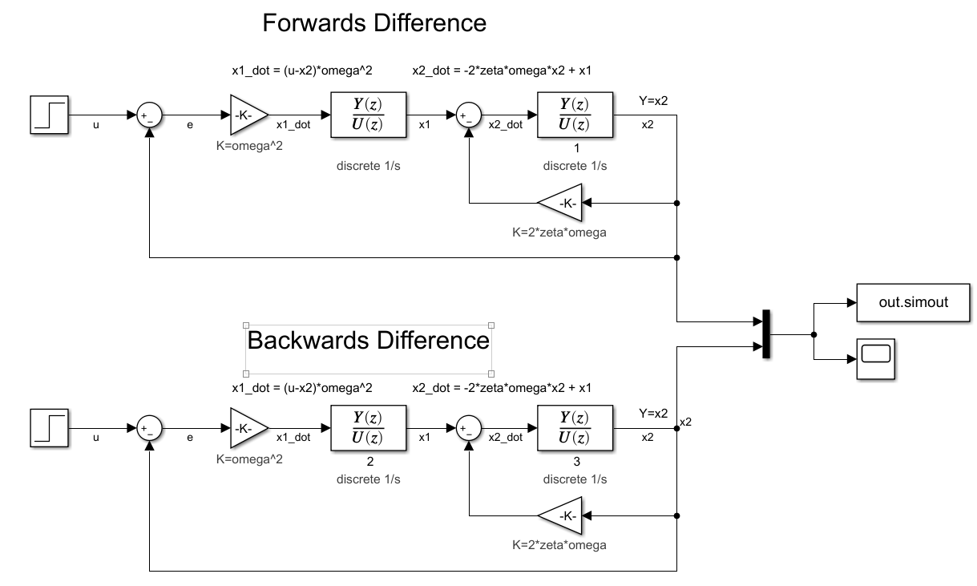

%define constants and array for dT

zeta = 1/sqrt(2);

omega = 294;

dT = [1 1/8 1/80 1/600];

figure('Color', [1,1,1]);

for i=1:length(dT)

%define z for ith timestep

z = tf('z',dT(i));

%forwards and backwards transform to replace s w/ z

s_f = @(z) (z-1)/dT(i);

s_b = @(z) (1-z^-1)/dT(i);

%get integrator transfer functions in terms of z

Hf = 1/s_f(z);

Hb = 1/s_b(z);

%get numerator and denominator arrays for simulink values

[num_f,dem_f] = tfdata(Hf, 'v');

[num_b,dem_b] = tfdata(Hb, 'v');

%run simulink model from [0 3] seconds and capture the outputs

output = sim('ESE_448_HW_1_simulink_model', [0 3]);

%ith subplot is (half width, half height, ith position)

subplot(2,2,i);

%plot forwards

plot(output.simout.Time, output.simout.Data(:,1),'LineWidth',1);

hold all;

%plot backwards

plot(output.simout.Time, output.simout.Data(:,2),'LineStyle', '-','LineWidth',1);

xlabel('Time (s)');

ylabel('Output');

%limit x, y so unstable parts aren't graphed

xlim([0 3]);

ylim([-1 3]);

title(['Forward vs Backward Euler with \DeltaT = ' num2str(dT(i))]);

legend({'Forward', 'Backward'},'Location','Best');

end